**IDEATION PHASE**

**Define the Problem Statements**

|  |  |
| --- | --- |
| Date | 24 APRIL 2023 |
| Team ID | NM2023TMID06135 |
| Project Name | AI car parking using open cv |

**Customer Problem Statement Template:**

Create a problem statement to understand your customer's point of view. The Customer Problem Statement template helps you focus on what matters to create experiences people will love.

A well-articulated customer problem statement allows you and your team to find the ideal solution for the challenges your customers face. Throughout the process, you’ll also be able to empathize with your customers, which helps you better understand how they perceive your product or service.

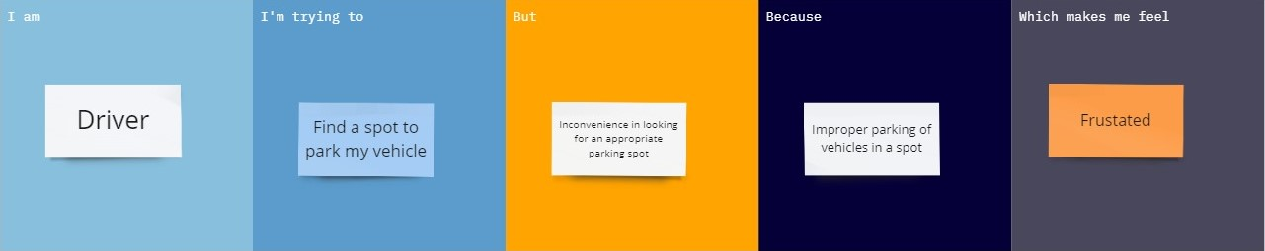

|  |  |  |  |  |  |
| --- | --- | --- | --- | --- | --- |
| **Problem Statement (PS)** | **I am** | **I’m trying to** | **But** | **Because** | **Which makes me feel** |
| PS-1 | Driver | Find a spot to park my vehicle | Inconvenience in looking for an appropriate parking spot | Improper parking of vehicles in a spot | Frustrated |
| PS-2 | Parking lot owner | Utilize the available parking area to its maximum | Cars are parked improperly | No proper technology is available | Exasperate |